Bangalore Traffic Analysis Report

1. Top 10 Most Congested Roads in Bangalore (Bar Chart)
This graph highlights the roads with the highest congestion levels across Bangalore.
Sony World Junction, Sarjapur Road, and Anil Kumble Circle show the highest average congestion.
All listed roads experience consistently heavy traffic, indicating major mobility bottlenecks.
The chart helps identify priority areas for traffic management and infrastructure planning.
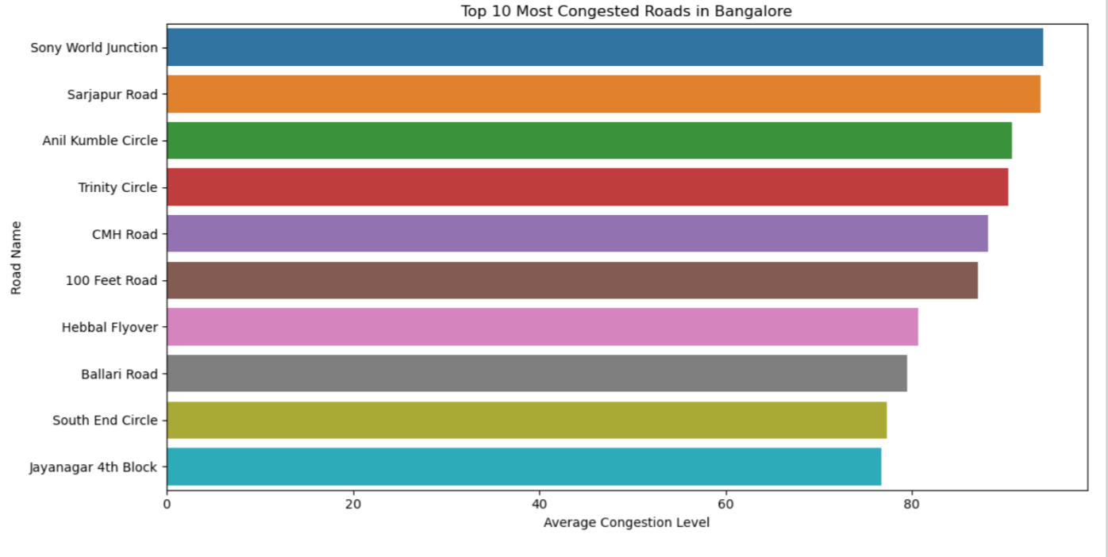

2. Average Traffic Volume by Area (Bar Chart)
This chart compares traffic volume across major Bangalore localities.
Koramangala and M.G. Road record the highest traffic, indicating dense movement and commercial activity.
Areas like Electronic City and Yeshwanthpur show relatively lower volumes.
The data helps understand travel demand patterns across the city.
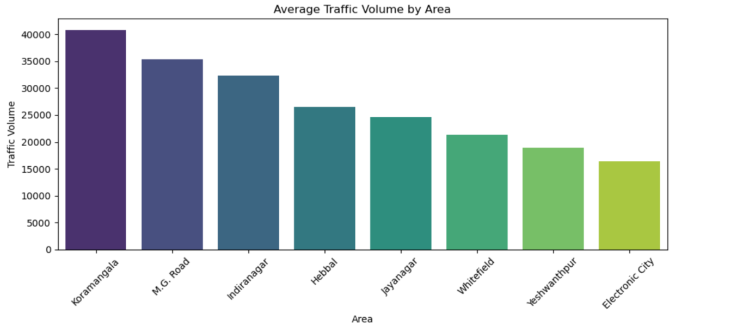

3. Incident Reports by Weather Condition (Bar Chart)
This graph shows the total number of traffic incidents under different weather conditions.
Clear weather records the highest number of incidents, likely due to higher vehicle movement.
Conditions like fog, rain, and wind have significantly fewer incidents comparatively.
The chart suggests weather plays a notable role, but high incidents in clear weather point to other contributing factors.
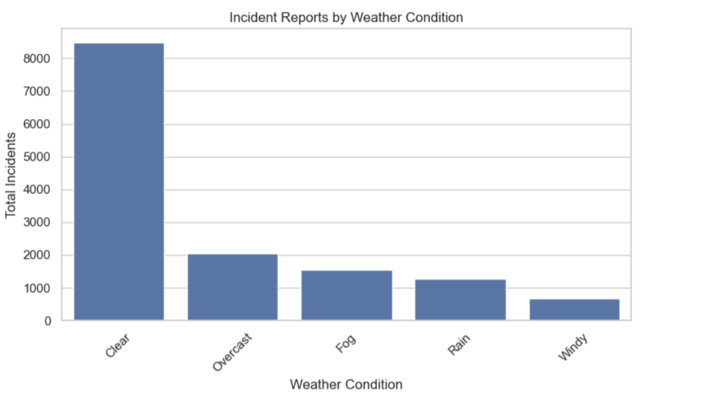

4. Traffic Volume Share by Area (Pie Chart)
This pie chart displays the percentage share of traffic contributed by each area.
Indiranagar, Koramangala, and M.G. Road together account for the largest share of total traffic.
Whitefield, Hebbal, and Jayanagar contribute moderate shares.
Electronic City has the smallest percentage, indicating lighter overall traffic demand.
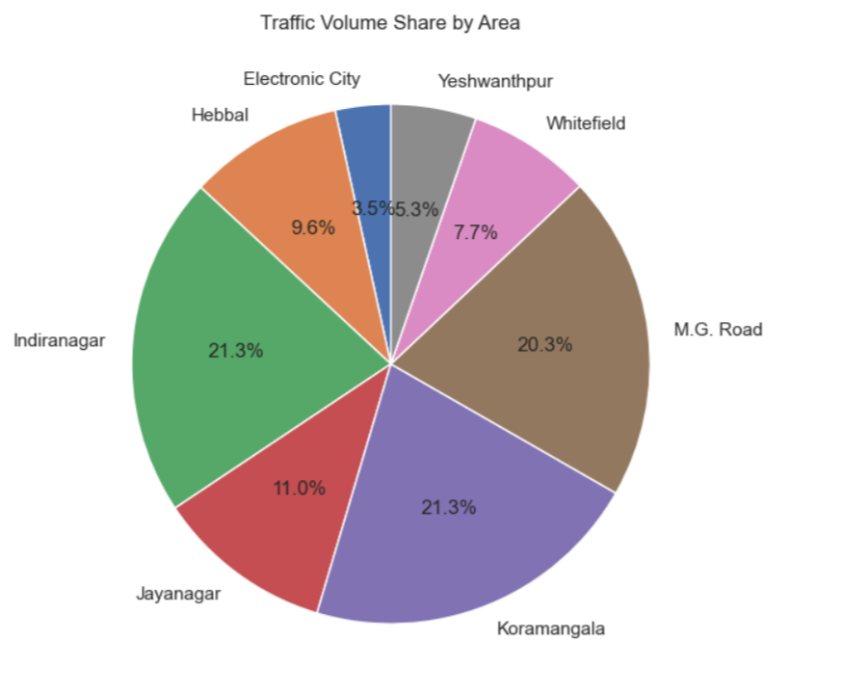

5. Incidents by Weather Condition (Pie Chart)
This chart represents how incidents are distributed across various weather categories.
Clear conditions dominate with over 60% of total incidents, showing most accidents happen during normal weather.
Overcast, fog, and rain collectively contribute a moderate portion of incidents.
Windy conditions show the lowest share, indicating fewer risks during such weather.
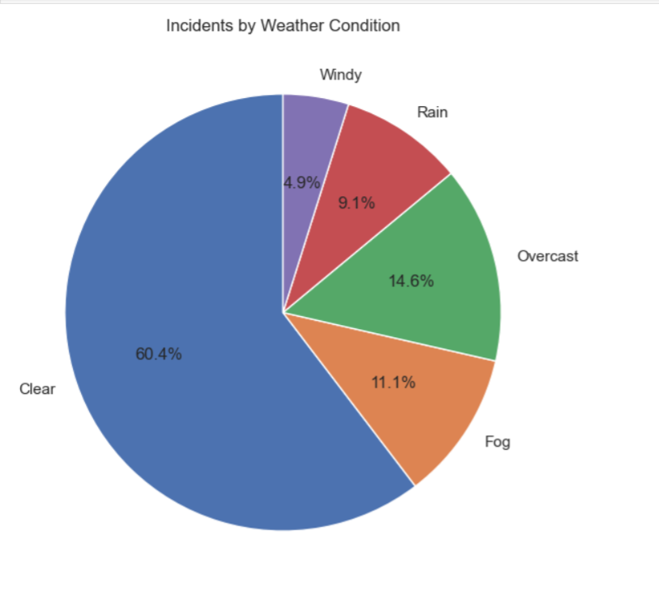

6. Traffic Volume Trend in Bangalore (Line Plot – Full Trend)
This graph shows the daily traffic volume trend over multiple years in Bangalore.
Traffic levels remain consistently high, with frequent peaks indicating heavy commuting periods.
There is significant variation day-to-day, reflecting fluctuating travel demand.
Overall, the trend suggests persistent congestion throughout the entire period.
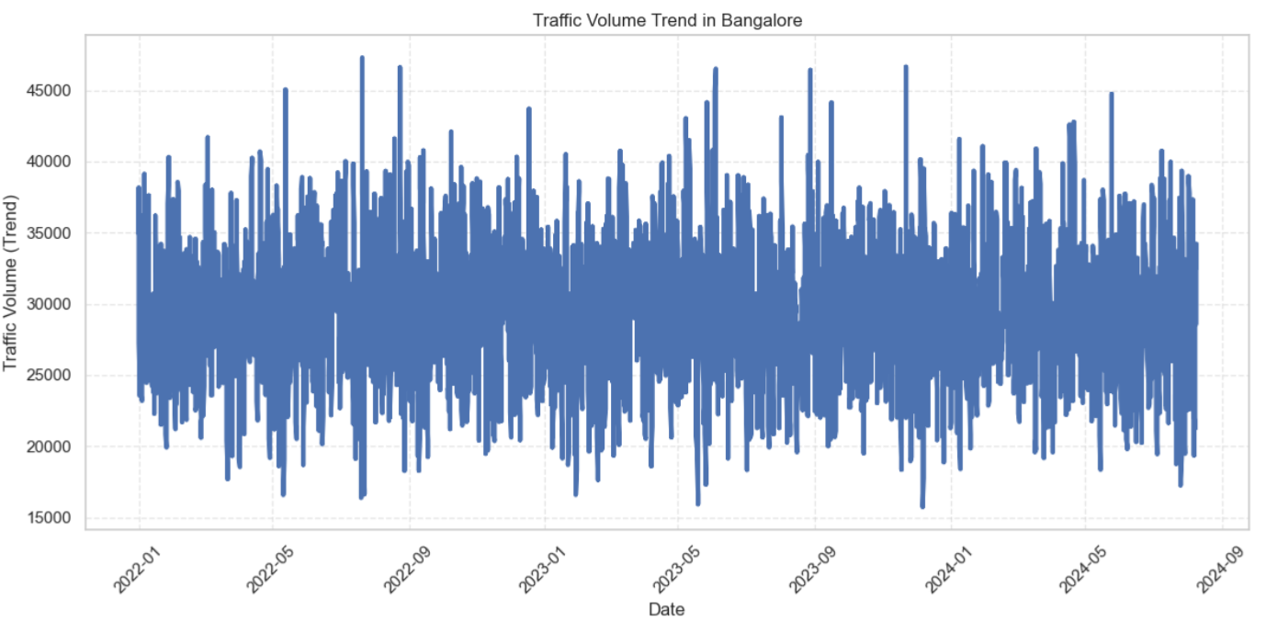

7. Traffic Volume Trend Over Time – Bangalore (Line Plot – Spiked Variation)
This graph highlights sharp fluctuations in traffic volume across the years.
High spikes suggest days of exceptionally heavy traffic, while drops indicate lighter traffic.
The pattern appears cyclical, possibly influenced by weekdays, weekends, or events.
Despite fluctuations, the average volume remains high, showing steady pressure on the road network.
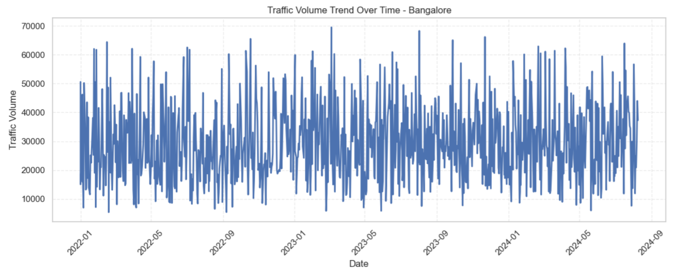

8. Congestion Level Trend Over Time – Bangalore
This graph illustrates congestion levels on a daily basis across two years.
Congestion frequently reaches the maximum level (near 100), indicating widespread peak-time saturation.
Sudden dips represent moments of lower traffic intensity, but these are less common.
The trend shows that Bangalore experiences consistently high congestion almost every day.

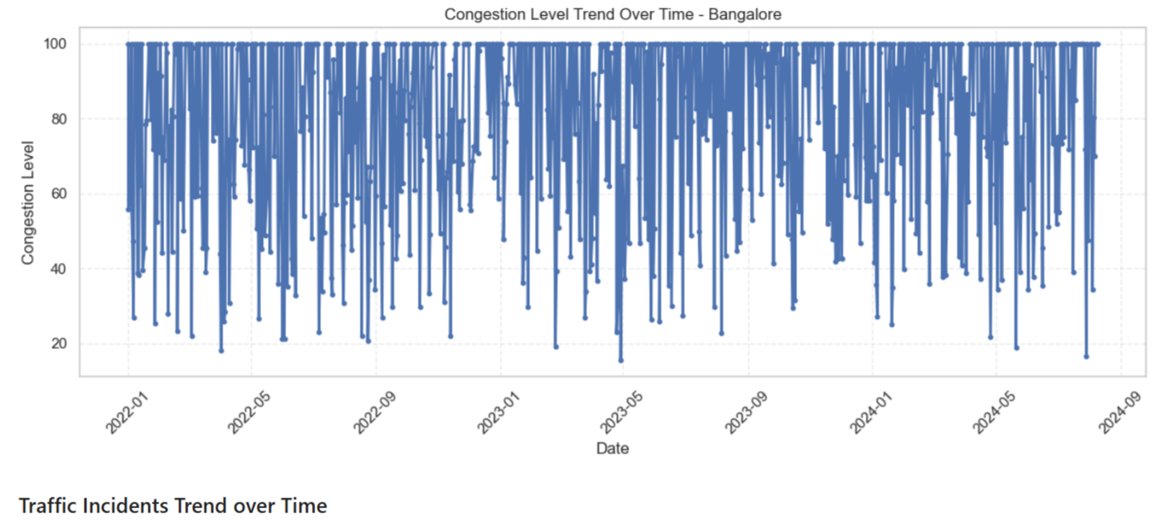

9. Traffic Incidents Trend Over Time – Bangalore
This graph tracks daily traffic incidents across the years.
The number of incidents fluctuates between 0 and 8, showing unpredictable patterns.
Occasional spikes indicate days with unusually high incident counts.
Overall, incident levels remain low but consistent, suggesting ongoing safety challenges.
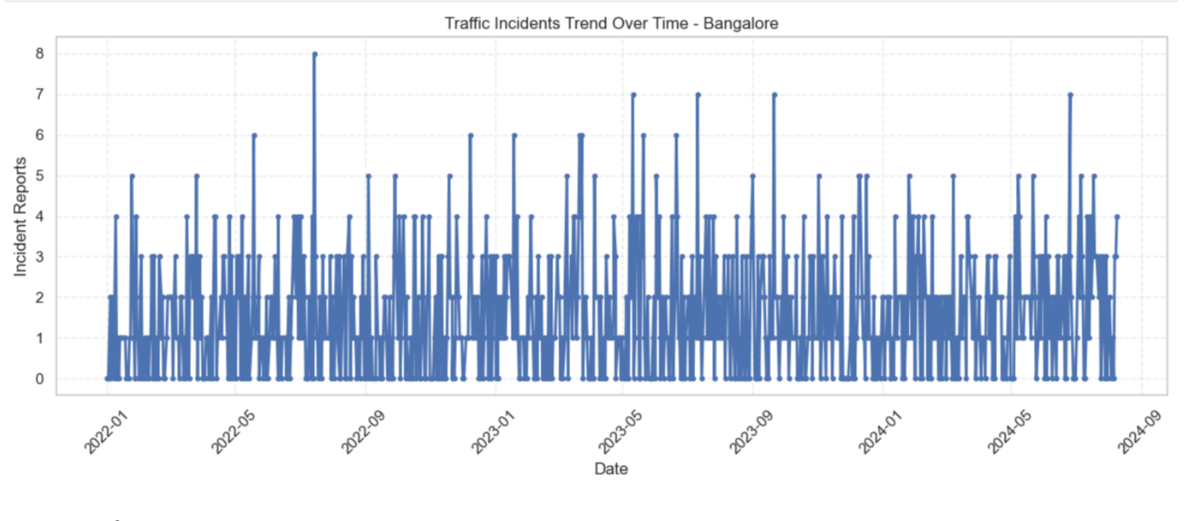

10. Traffic Volume vs Average Speed (Scatter Plot)
This scatter plot shows the relationship between traffic volume and average speed.
As traffic volume increases, the average speed tends to decrease, indicating congestion effects.
Most data points cluster in the mid-volume range where speeds vary significantly.
The trend clearly highlights the inverse relationship between road load and travel efficiency.
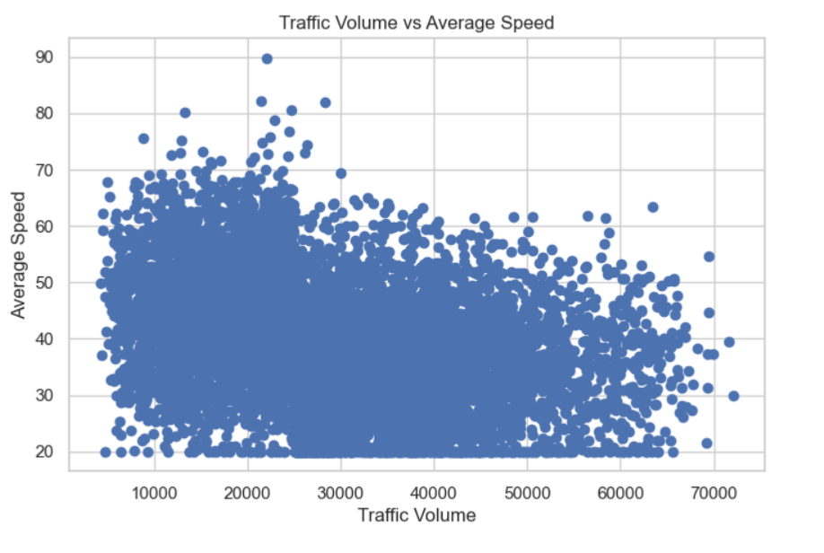

11. Congestion Level vs Travel Time Index
This scatter plot shows the relationship between congestion level and travel time index. The data points are widely spread with no strong visible correlation, indicating that travel time index remains relatively stable across different congestion levels. A cluster appears at higher congestion values, suggesting many instances of maximum congestion.
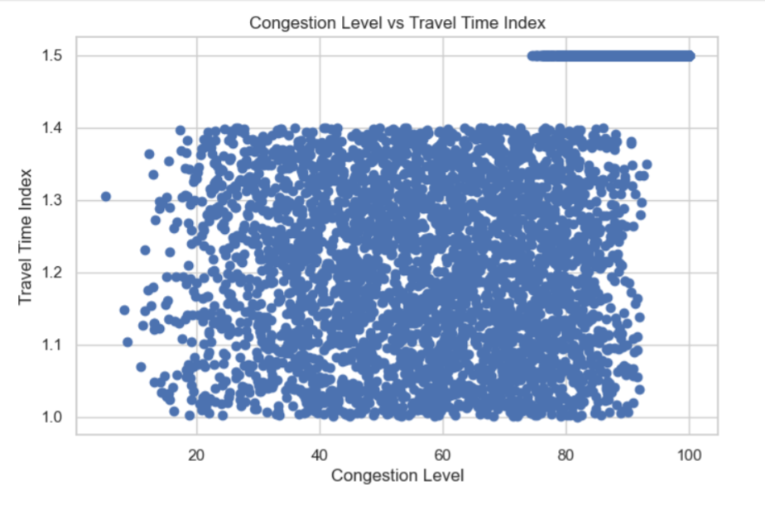

12. Incident Reports vs Traffic Volume
This chart depicts traffic volume against the number of incident reports. Traffic volume varies widely for each incident count, showing no linear relationship. Higher incident counts appear less frequent, with most data concentrated in the lower incident range.

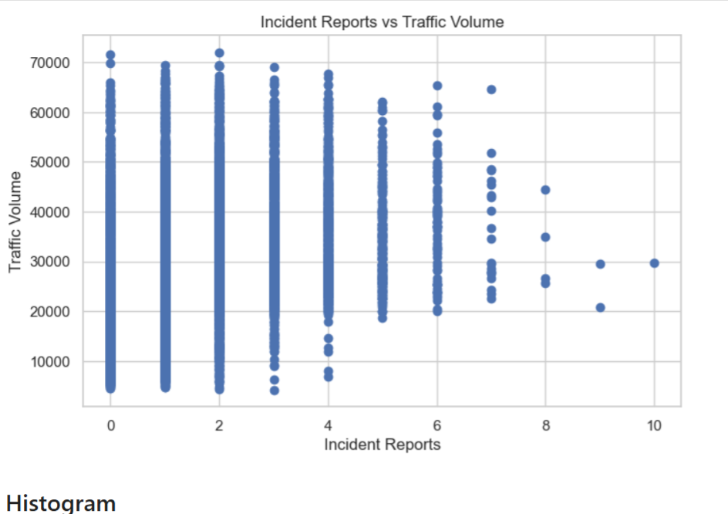

13. Distribution of Traffic Volume (Histogram)
The histogram displays the distribution of traffic volume values. The distribution is roughly right-skewed, with most volumes falling between 15,000 and 35,000. Higher volumes above 50,000 are less common.
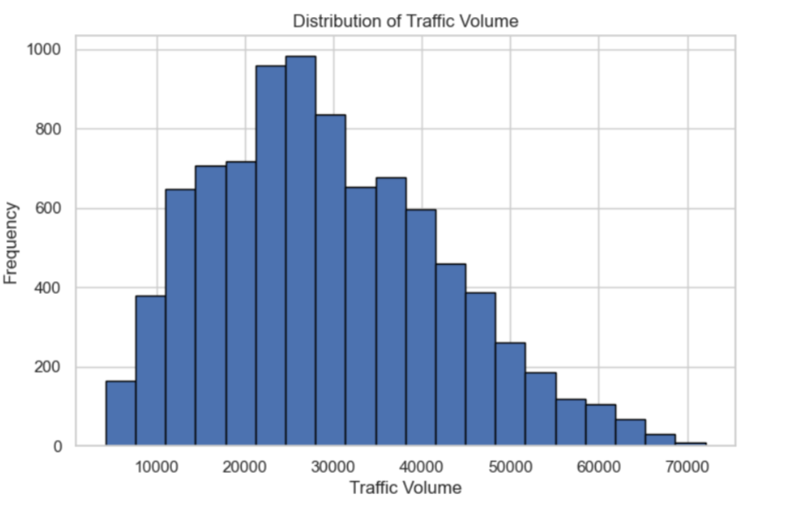

14. Congestion Severity Distribution
This histogram illustrates how often different congestion levels occur. There is a sharp rise at the highest congestion value (100), indicating many extreme congestion cases. Lower congestion levels appear progressively less frequent.
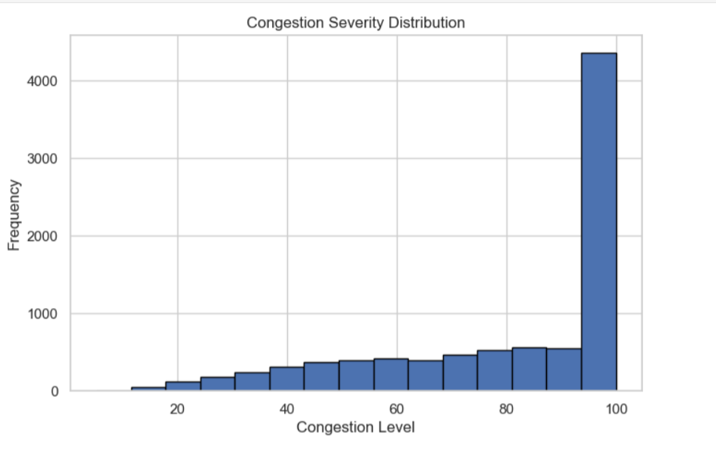

15. Incident Report Distribution
This histogram shows the frequency of incident report counts. The distribution is heavily skewed toward the lower end, with most cases having 0–2 incidents. Higher incident counts (5+) are rare.
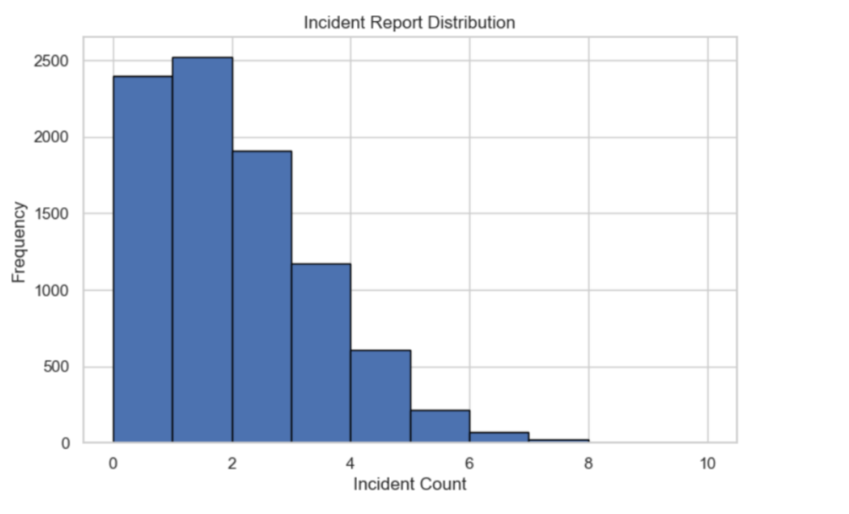

16. Traffic Congestion Pyramid by Area
This chart compares low vs high congestion counts across major city areas. Areas like Koramangala, M.G. Road, and Indiranagar show significantly higher high-congestion counts than low-congestion ones. Meanwhile, places like Electronic City have relatively lower congestion numbers overall. The pyramid layout makes it easy to contrast congestion severity by region.
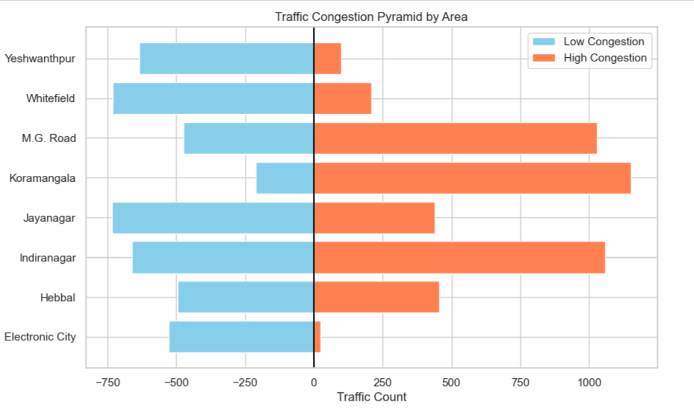

17. Top 5 Most Congested Areas
This line chart ranks the five areas with the highest average congestion levels. Koramangala and M.G. Road top the list with congestion levels above 90. The congestion gradually decreases across Indiranagar, Hebbal, and Jayanagar. Overall, the chart highlights the worst-affected regions in the city.
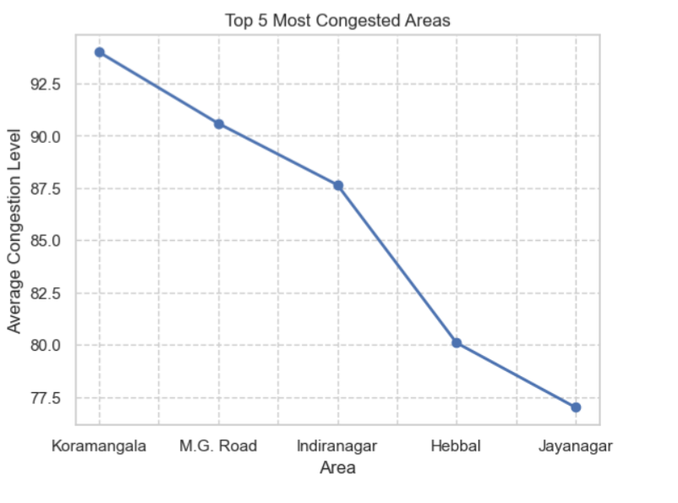

18. Traffic Volume vs Congestion Level
The scatter plot shows a clear upward trend between traffic volume and congestion level. As traffic volume increases, congestion rises sharply until it saturates at the maximum congestion value of 100. This indicates a strong positive correlation between the two variables. High-volume traffic consistently leads to extreme congestion levels.
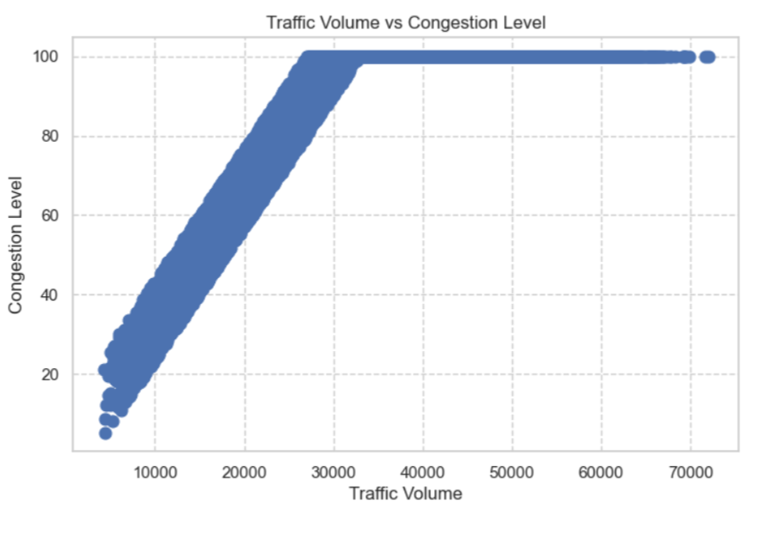

Bangalore Monthly Congestion Level Forecast for 2025
This line chart compares historical monthly congestion levels with predicted congestion for 2025. The historical data fluctuates between 79 and 84, showing typical seasonal variation. The forecast for 2025 indicates a stable trend around 80–81, with minor ups and downs. Overall, the prediction suggests no major rise in congestion levels for 2025.
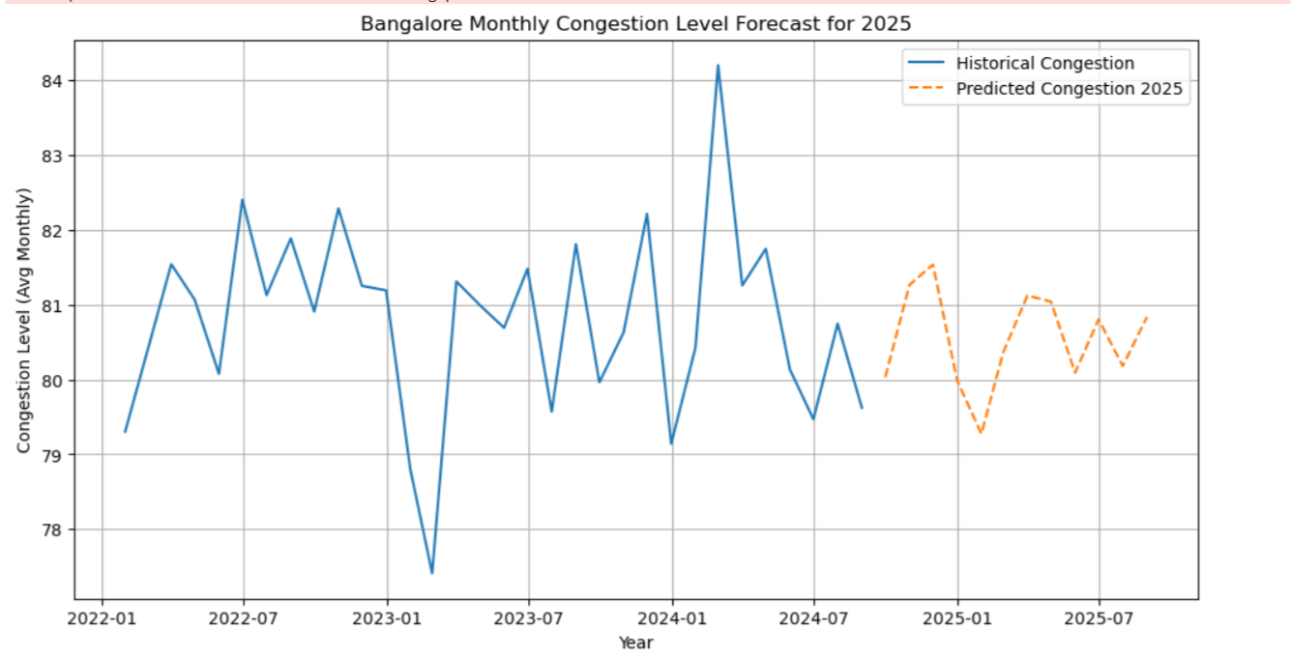

Monthly Weather Trends in Bangalore
This chart visualizes the number of days per month experiencing different weather conditions over several years. Clear weather dominates each month, with counts consistently above 150 days. Overcast, fog, rain, and windy days remain much lower and relatively stable, showing minor seasonal peaks. The sharp drop in the final month reflects incomplete data or seasonal transition.
